ITSC 3155 Final Exam
- Question 1
  - Software modeling is used to design/plan the software applications before the actual software coding is done and it helps organize, visualize, understand what the will be like overall.
  - Software modeling tools are needed, because it helps with the designing of software applications and can help in identifying issues in the software model, test the software model under various situations, and etc…
  - Software modeling can be used to analyze and determine an estimate on how much work/time is needed to complete the system, and can also provide an analysis on what type work needed(like design, database, etc…).
- Question 2
  - Idea: Fast Food Restaurant Tools system receives orders placed and then displays the best order to make food in and also displays ingredients required for the selected menu. Example: For a Chinese restaurant, the tool system would use an algorithm to calculate the amount of orders placed, the time the order was placed and display it in an optimized order to make the food.
  - Two User Stories for the system
    - US-1: Display Optimized Orderlist
      - Type of User: Chef
      - Description: As a chef, I want to be able to view optimized orders list for food to be made, so that I can cook in an efficient manner which will prevent orders from being delayed and causing long wait time for customers
    - US-2:
      - Type of User: Chef
      - Description: As a chef, I want to be able to select to view the list of needed ingredients from the order list, so that I can gather the needed ingredients efficiently which helps speed up the cooking process.
  - 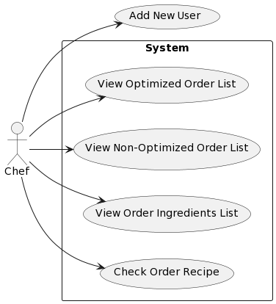
  - 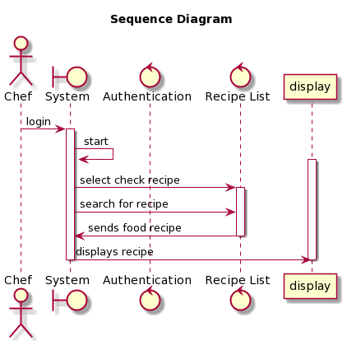

- Question 3
  - Planning, Analysis, Design, Implementation, Testing & Integration, Maintenance
  - General Idea is people over process, the principles of Agile Software Development is to streamline their product-development cycles and achieve better results through a flexible, reactive system by using an iterative way of managing projects and developing software that makes it easier for teams to deliver value to their customers more quickly and effectively.
  - Two principles of Agile Software Development relevance to group project
    - The 1st principle was Working Software, our team prioritized working functions over making detailed customized function and web page designs.
    - The 2nd principle was Reflect and Adjust. When we learned that some testing wasn’t possible in a short period of time, we decided to prioritize other more important functions first.
- Question 4
  - Fowler considers software architecture to be decisions which are both important and hard to change. This includes programming language of choice and when decisions are made poorly it can make a project either fail expensively.
  - Software Design is individual modules and parts of the software while software architecture is the overall structure of the individual modules and parts of the software making a system.
- Question 5
  - There are different types of test development, we used TDD in class
    - Test-driven development (TDD):
      - Write tests before writing code
      - Aspects of the implementation are not fully known
      - Tests are used to guide development
  - Benefits of Test-Driven Development
    - Bugs are often found early in the development process
    - Tests can reveal design flaws before they become a problem
    - Tests can help document the behavior of the code
    - Verification that the code works as expected
    - Strongly encourages modular code
- Question 6
  - What problems does version control solve?
    - Helps keep track changes to code as you work
    - if someone on your team breaks something, you can revert to previous versions
    - Collaborate with others on the same codebase without causing conflict error/issues
    - Keep a history of your codebase which can help understand progress of code
  - Github uses distributed version control while google uses its own version control tool aka piper which is a centralized version control.
- Extra Credit
  - For the implementation phase of the project the instructions, I wished that the instructions were more detailed, as current instruction caused me little confusion. The instruction only says to implement our functions, when I first read the instructions, I thought “Are we supposed to implement the requirements only or also the use cases as well?”. Also wished that there was a team report assignment on canvas for each phase for team members to fill out to check if everyone was properly participating, this can help determine if a team member is inactive and is being carried and receiving a good grade for doing no work.

